
VILNIUS GEDIMINas Technical university
Faculty of Electronics
department of Electrnics systems

Machine Learning
Practical work 2
Authors: Kirill Postrehan, EDIfu 24/1
Lecturer: Dr. Olusola Oluwakemi Abayomi Alli

VILNIUS 2026
Introduction:
During this laboratory work I will use the dataset I got from scraped website with books and employ unsupervised machine learning algorithm K-Means to define “genres” for books based on their price and rating. Then I will try to classify books using Multi-Layer Perceptron and check metrics.

Analysis & visualizations:
I enerated a word cloud and it turned out that the highest keyword in the titles is “Love”.

First thing first, I preprocessed the dataset in order to use it on K-Means and find the optimal number of clusters I need. I found out that the best option is 4 clusters based on inertia, silhouette and Davies-Bouldin index. Their graph clearly show us that.
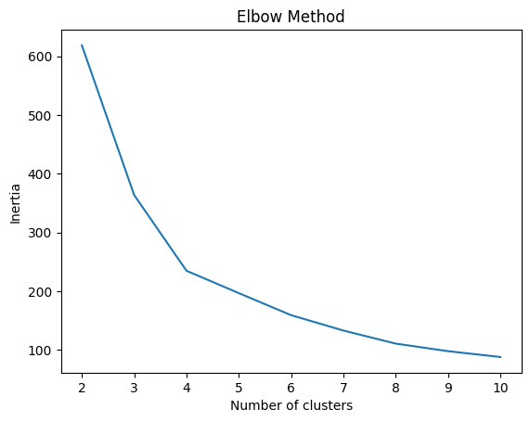
(pic. 1. Inertia)

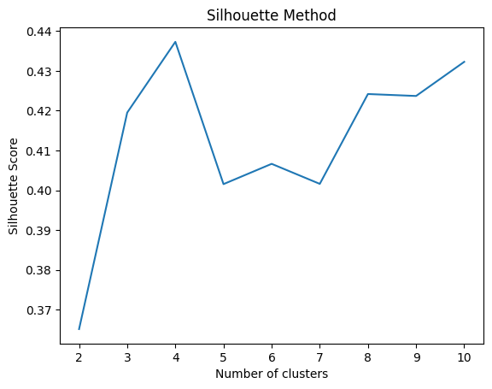
(pic. 2. silhouette)

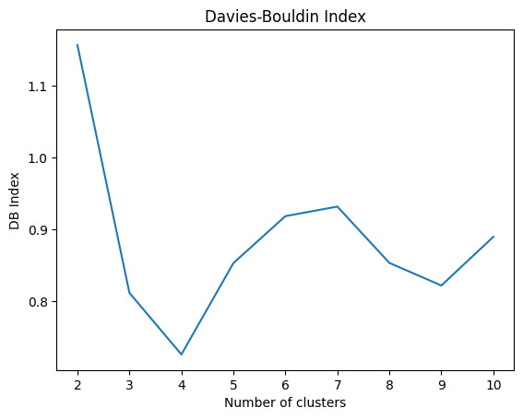
(pic. 3. Davies-Bouldin Index)

All of them indicate that 4 clusters are the best.
I defined a dictionary of 4 random genres with corresponding cluster number and mapped them to get genre label.
The dataset of clustered books look as follows:
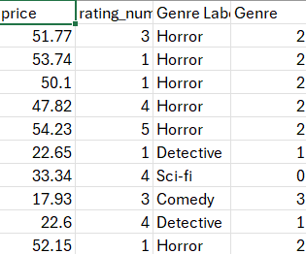
(pic. 4. dataset of clustered books)

Then, using torch I created class MLP with the following architecture:
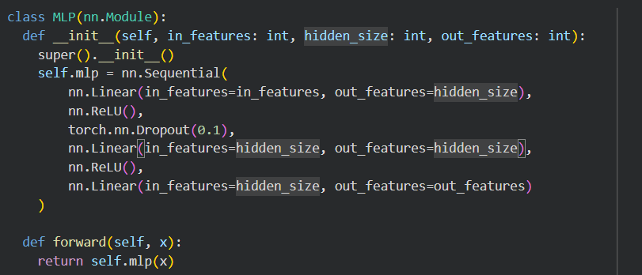
(pic. 5. the code for MLP class)
After finishing with preparing dataloaders and training function I started training the instance of MLP class. In order to reach roughly 95% accuracy and and 0.32 loss I experimented with different hyperparameters like number of epochs, hidden units, learning rate and its decay to find that 70 epochs, 20 hidden units and learning rate of 0.001 is what i needed.
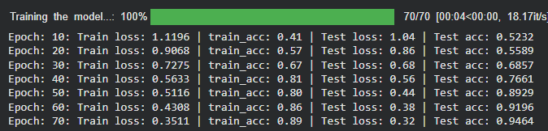
(pic. 6. The result of training)
Then I used metrics imported from torchmetrics library and got the following result:
(pic. 7. machine learning metrics)
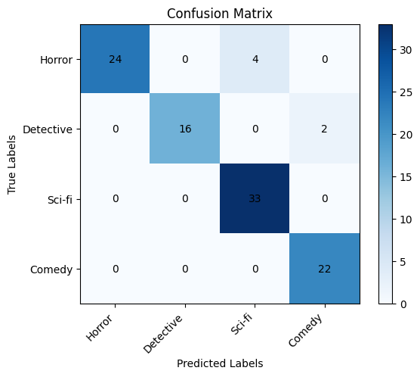
(pic. 8. confusion matrix)

Conclusion:
In this practical work, K-Means clustering was used to identify four optimal clusters in the book dataset based on price and rating . Random genres were selected to represent these 4 clusters and later classified using a Multi-Layer Perceptron (MLP). After tuning hyperparameters, the model achieved about 95% accuracy with low loss, and evaluation metrics confirmed strong performance.

